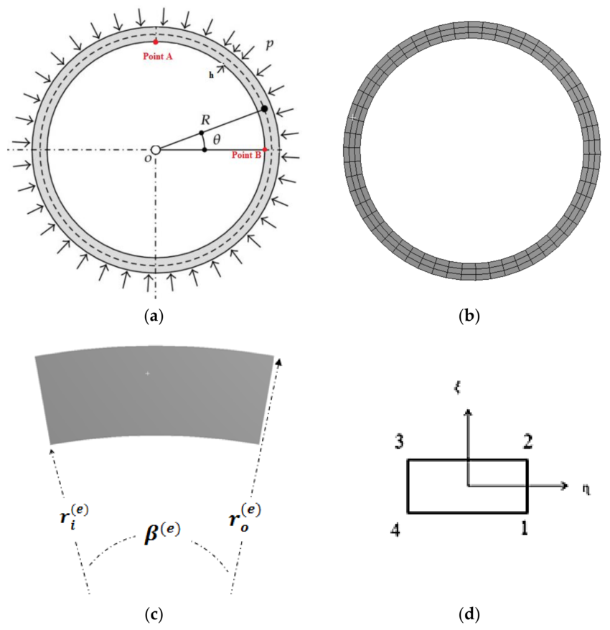
Segments
Base plate segment
input
- Dbp = base plate diameter (ft or in)
- Ro = base plate outside radius
- Ri = base plate inside radius
- θ = base plate segment angle (deg)
- t = base plate thickness (in)
- n = number of base plate segments
- rs = steel unit weight = 490 pcf
- Nh = number of anchor bolt holes in one segment
- dh = diameter of anchor bolt hole
- α = start angle of segment (deg), if you want location in plan
- rb = bolt circle radius, if bolt layout is needed
Output
- Gross area, $A_{g}$
$$A_{g}= \frac{θ}{360}π (R_{0}^{2}- R_{i}^{2})$$
- Net area, $A_{n}$
$$A_{n}=A_{g}- N_{h}( \frac{πd_{h}^{2}}{4} )\frac{1}{144}$$

- Volume, $V$
$$V= A_{g}(\frac{t}{12})$$

- Weight per segment, $W_{bp}$
$$W_{bp}= A_{g}( \frac{t}{12}) ( \frac{r_{s}}{1000}$$
- Total weight, $W_{bp,total}$
$$W_{bp,total}=n .W_{bp}$$
- Outer arc length, $L_{o}$
$$L_{o} =R_{0} .θ_{r}$$
- Inner arc length, $L_{i}$
$$L_{i} =R_{i} .θ_{r}$$
$$θ_{r}= θ(\frac{π}{180})$$
- Radial width, $b$
$$b =R_{0} .R_{i}$$
- Centroid radius, $\overset{ˉ}{r}$
For one segment, the centroid lies on the segment centerline:
$$\overset{ˉ}{r} = \frac{4sin(θr​/2)}{{3θ}_{s}} x \frac{R_{0}^{3}- R_{i}^{3}}{R_{0}^{2}- R_{i}^{2}}$$

- Centroid angle of segment
$$β= ∝ + \frac{θ}{2}$$

- Centroid coordinates, $\left(x_{c} , y_{c}\right)$

$$x_{c}= \overset{ˉ}{r}cosβ$$
$$y_{c}= \overset{ˉ}{r}sinβ$$

